**AIM:** To describe Data flow diagram (DFD).

**THEORY:**

*Def****:*** A diagram to show how data is captured, processed , stored and distributed within a system. This is generally represented during the analysis stage of a project, but can be further refined during the design stage to show more detail of how the system functions.

*Description*: Data flow diagramming shows business processes and the data that flows between them. It is often impossible to represent a complete business on one diagram. For this reason it is quite common to use more than one level of Data Flow Diagram with each level showing more detailed information about part of the previous diagram.

It is important that the diagram should be made as clear as possible and for this reason it is not uncommon to draw the same source or sink [external entity] more than once to help achieve this.

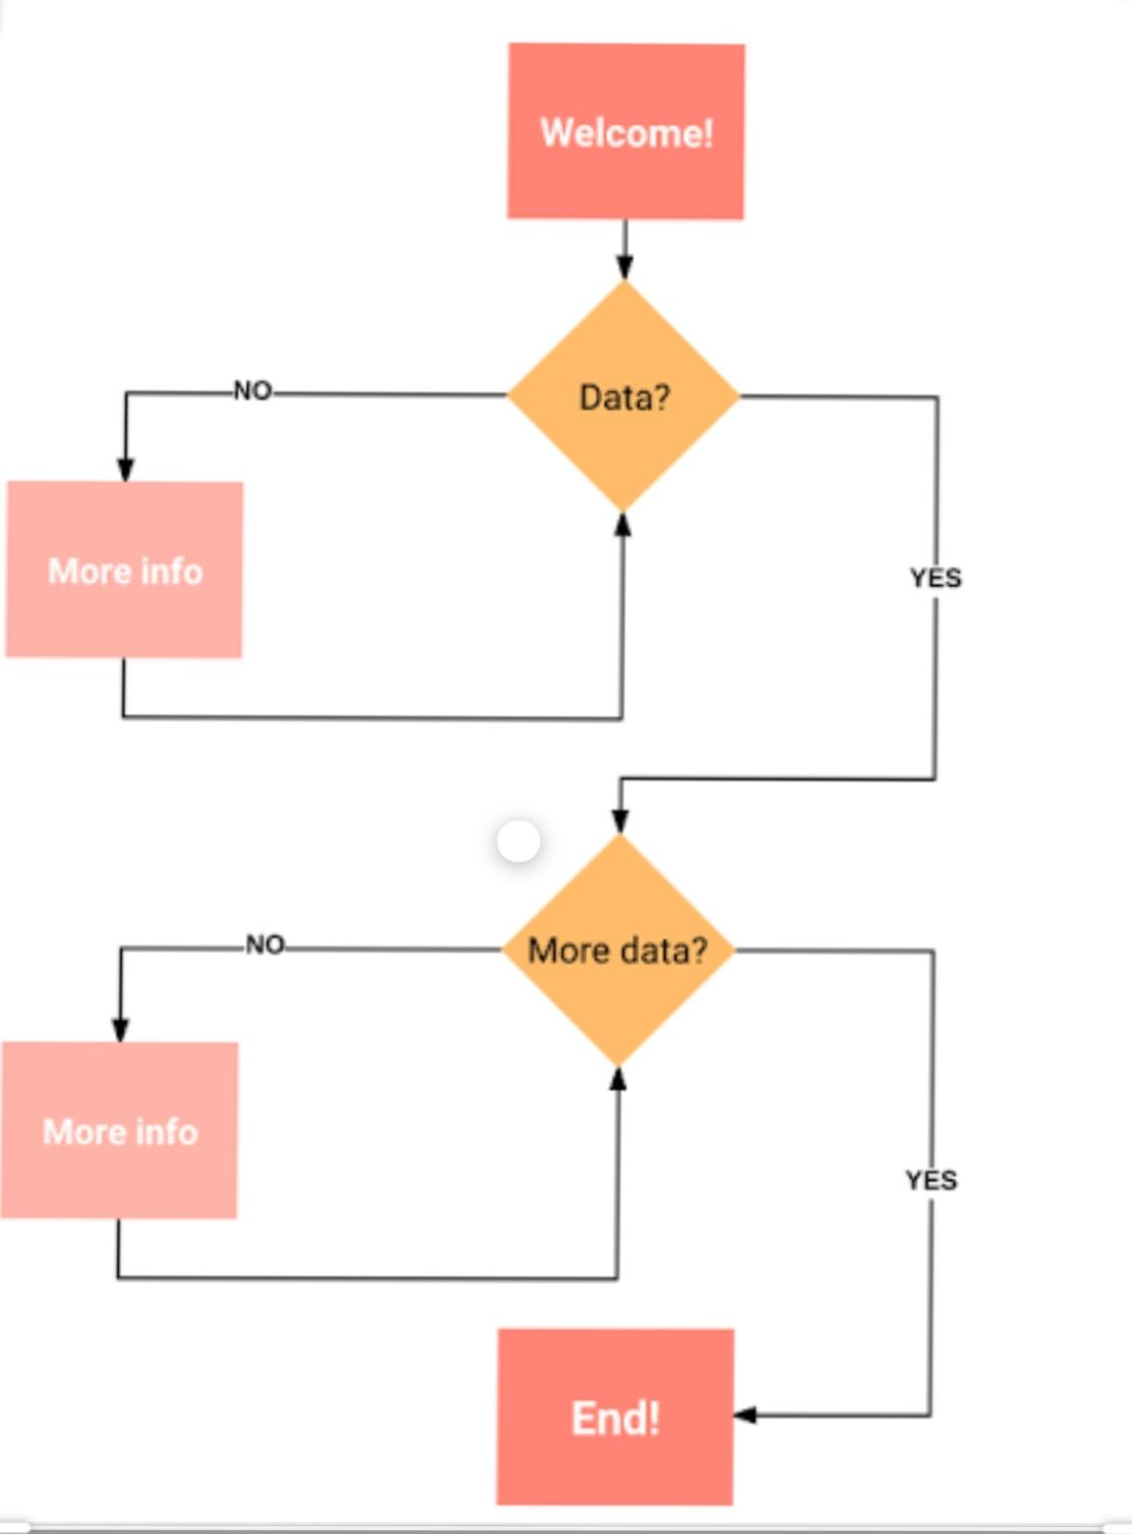***Components****:*

**Uses:** During the analysis stage of a project it is important to find out how data flows through a system:

* Where does the data originate
* What processing is performed on it and by whom
* Who uses the data
* What data is stored and where
* What output is produced and who receives it

*Data flow diagrams would be used to model the logic of data flows in a virtual assistant (chatbot)*

* ***. Context or Level 0 Diagram***
* Identify where data is captured from
* Identify where data is distributed to
* Describe the overall process
* Map these out in a diagram using the correct symbols
* Link them with data flows that are labelled

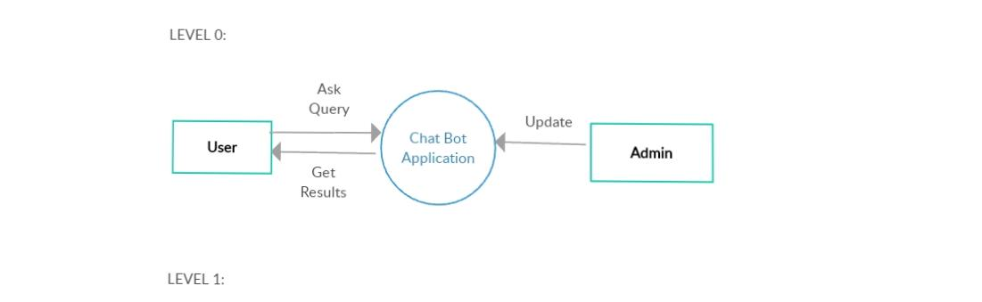

***Constructing a Level 1 diagram:***

* + Identify and draw the processes that make up the Level 0 process
  + Allocate descriptions to these
  + Lay out the sources/sinks and data flows from the Level 0 diagram
  + Draw in any data stores used in the process
  + Link the new processes and data stores with named data links.

***Level 1 diagram:***

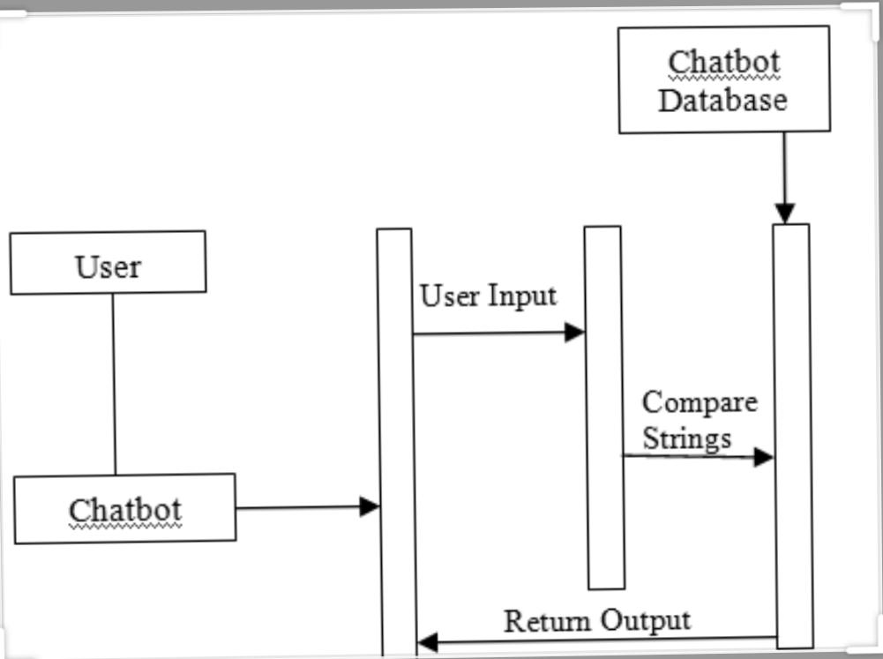

**CONCLUSION:**

The Data Flow Diagram (DFD) is an essential tool for creating formal descriptions of business processes and data flows.

Use cases record the input, transformation, and output of business processes.

Eliciting scenario descriptions and modeling business processes are critically important skills for the systems analyst to master.